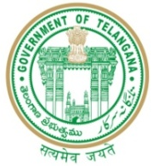

GOVERNMENT OF TELANGANA
TELANGANA TRIBAL WELFARE RESIDENTIAL DEGREE COLLEGE (GIRLS), MAHABUBABAD: MAHABUBABAD-DIST
https://www.ttwrdcs.ac.in/Mahabubabad
E-Mail Id:ttwrdcgirls.mahabubabad@gmail.com Cell No: 7901097695

29 June 2024
The Department of statistics has planned to conduct poster presentation competition on the occasion of National Statistics Day 29 June 2024.

Programme: Poster presentation competition.

Team No | Name of the student | Class | Title of poster
1 | E.Manasa | III MSCs | Types of Graphs
2 | U.Shailaja | III MSCs | Probability
3 | T.Shravani | III MSCs | Measures of Dispersion
4 | B. Preethi | III MSCs | Curve Fitting
5 | E. Monika | III MSCs | Statistics Special Symbols
